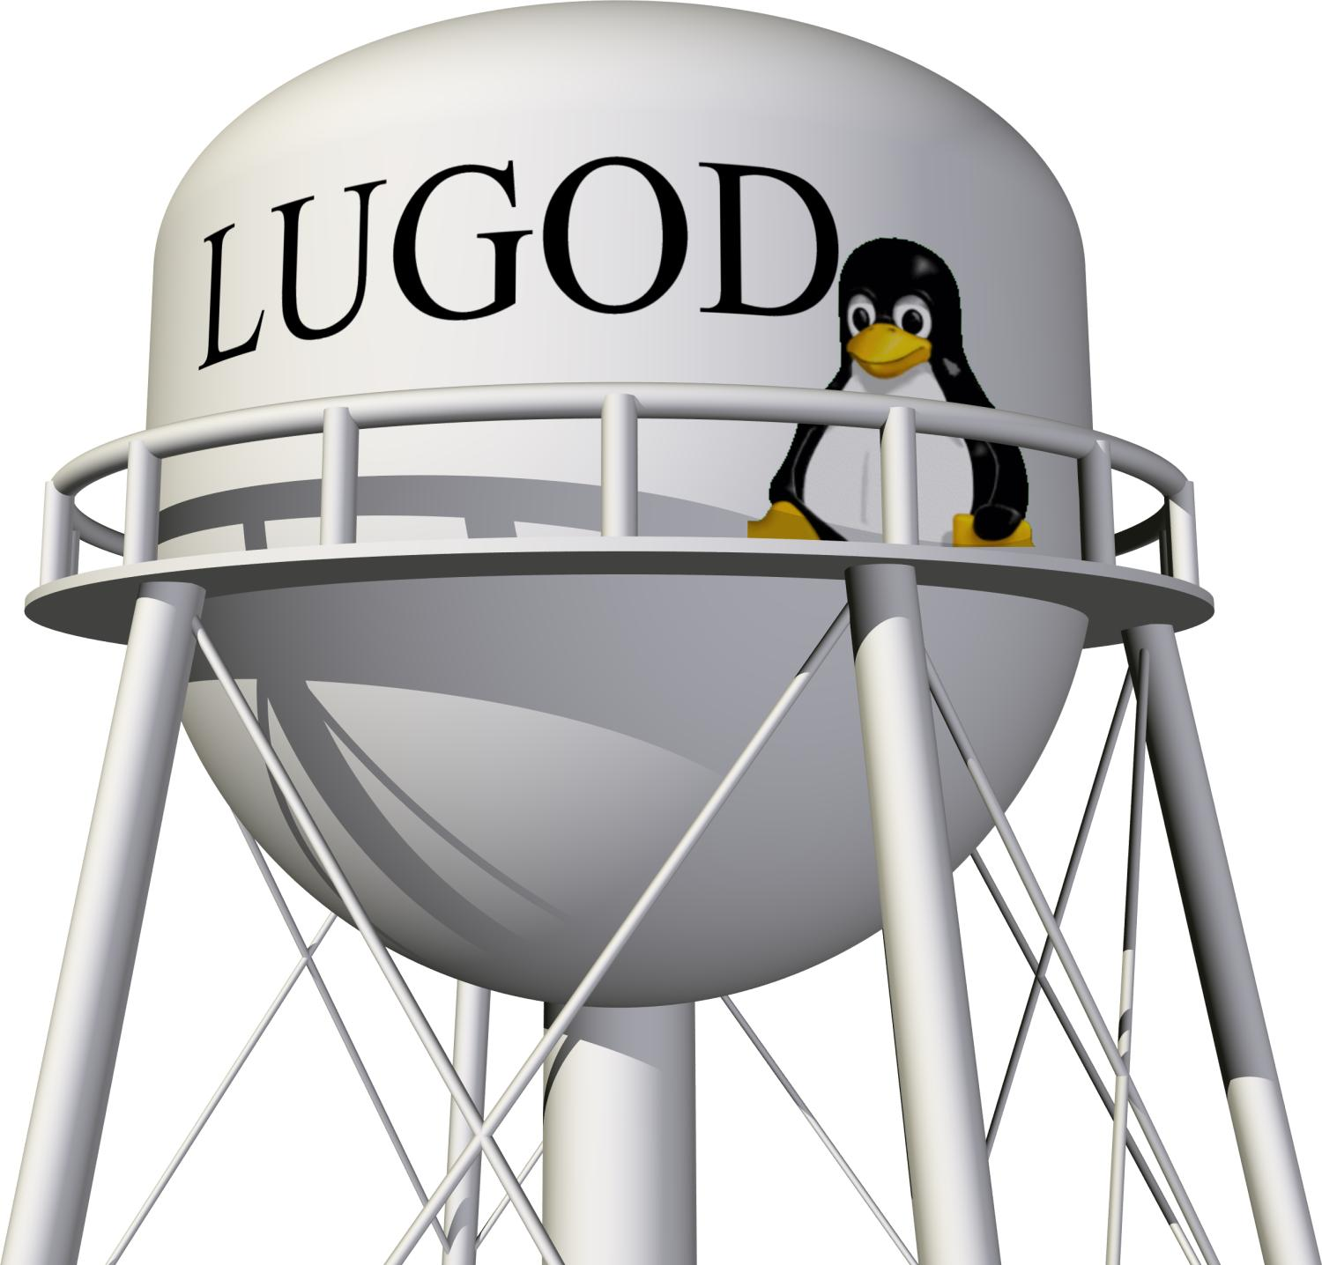

The Linux Users' Group of Davis presents:
Hacking Space Exploration & Science
An informal and personal talk about what it means to hack space exploration and science, why it's important, the motivations behind it, and what it means for the future of science.
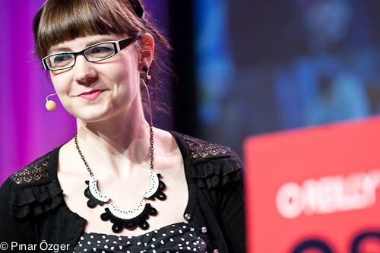
With Ariel Waldman, creator of Science Hack Day SF and Spacehack.org. She also is an interaction designer and Research Affiliate at the Institute For The Future. Previously, she worked at NASA's CoLab program whose mission was to connect communities inside and outside NASA to collaborate.
Spacehack.org is a directory of ways to participate in space exploration, interact + connect with the space community and encourage citizen science. Its conception was influenced by the NASA Authorization Act of 2008.
The mission of Science Hack Day is to get excited and make things with science! A Hack Day is a 48-hour-all-night event that brings together designers, developers, scientists and other geeks in the same physical space for a brief but intense period of collaboration, hacking, and building 'cool stuff.'
Monday  October 17, 2011  7pm – 9pm | Davis Public Library  315 East 14th Street  Davis, CA 95616

Free & open to the public!
www.LUGOD.org

Pinwheel Galaxy photo: http://www.flickr.com/photos/jaredsmith/176375861/ CC BY-SA 2.0
Ariel Waldman photo: http://www.flickr.com/photos/oreillyconf/5982655953/ CC BY-NC 2.0

